**STRUCTURE OF WEB BROWSER**

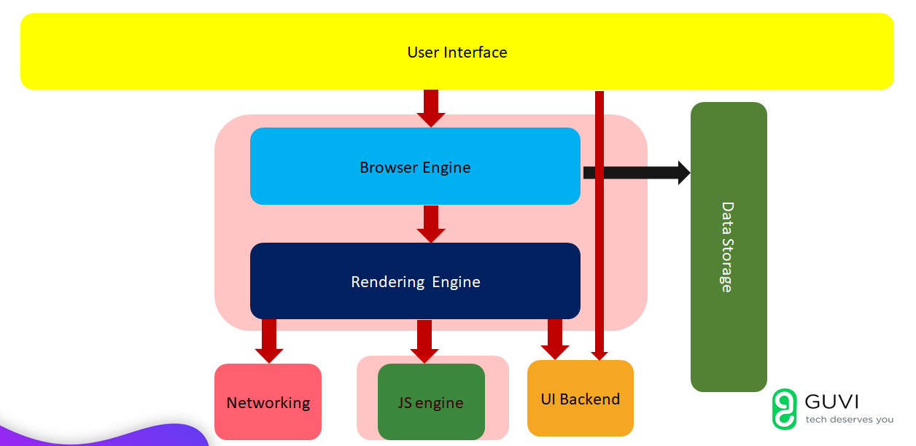

**Web Browser** is an application software that allows us to view and explore information on the web.

There are 7 major components of web browser:

* USER INTERFACE
* BROWSER ENGINE
* RENDERING ENGINE
* DATA STORAGE
* NETWORKING
* JS ENGINE
* UI BACKEND
* User interface interacts with browser engine and UI backend. A user interface provides a allows the user to interact with the software or hardware in a natural and intuitive way.
* The primary job of a **browser engine** is to transform HTML documents and other resources of a web page into an interactive visual representation on a user's device. The browser engine further interacts with rendering engine and data storage.
* A **rendering engine** is software that draws text and images on the screen. The engine draws structured text from a document (often [HTML](https://developer.mozilla.org/en-US/docs/Glossary/HTML)), and formats it properly based on the given style declarations (often given in [CSS](https://developer.mozilla.org/en-US/docs/Glossary/CSS)). Examples of layout engines: [Blink](https://developer.mozilla.org/en-US/docs/Glossary/Blink), [Gecko](https://developer.mozilla.org/en-US/docs/Glossary/Gecko), EdgeHTML, [WebKit](https://developer.mozilla.org/en-US/docs/Glossary/WebKit).

|  |  |
| --- | --- |
| WEB BROWSER | RENDERING ENGINE |
| Chrome | Blink |
| Mozilla | Gecko |
| Internet Explorer | Trident |
| Microsoft Edge | EdgeHTML |

* **JavaScript** is a multi-paradigm prototype-based language, which uses **JavaScript Engine such as Chrome’s V8 engine Firefox SpiderMonkey engine and etc.** They convert the high level code into machine-readable code which lets computer to perform some specific tasks.

|  |  |
| --- | --- |
| WEB BROWSER | JS ENGINE |
| Chrome | V8 |
| Mozilla | SpiderMonkey |
| Internet Explorer | Chakra |
| Microsoft Edge | Chakra |